**ASSIGNMENT 3- A simple RESTFUL API using React.js, DataBase Creation, and Creating Index**

**RestFul API code**

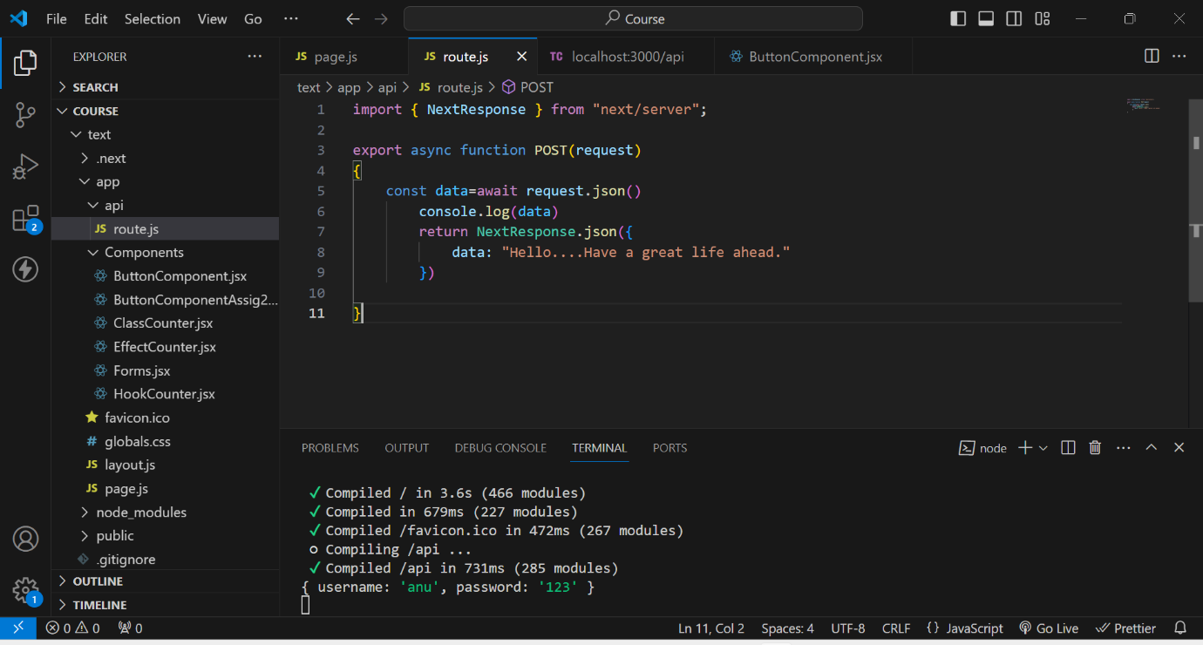

**Rest Output on ThunderClient**

**This is the output when we create an API using REST.**

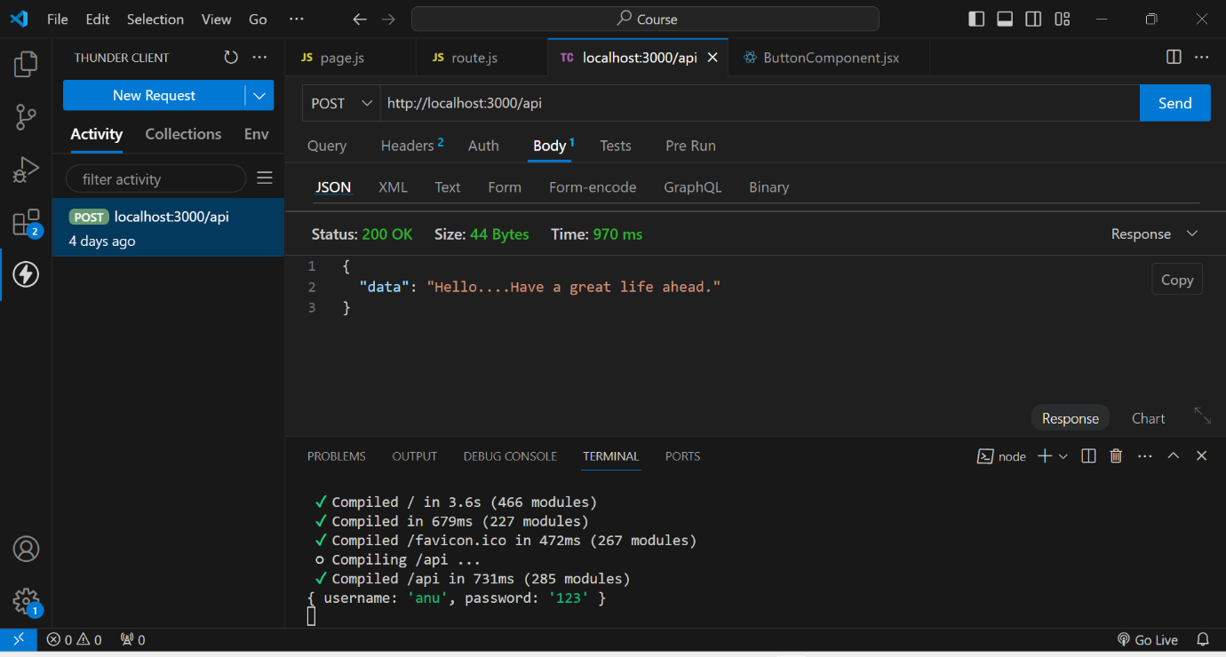

**DataBase Creation**

**1st we created a database named test**

**In that test we created a collection named Students**

**And finally by using ADD DATA , we added data of the students like rno, name, age.**

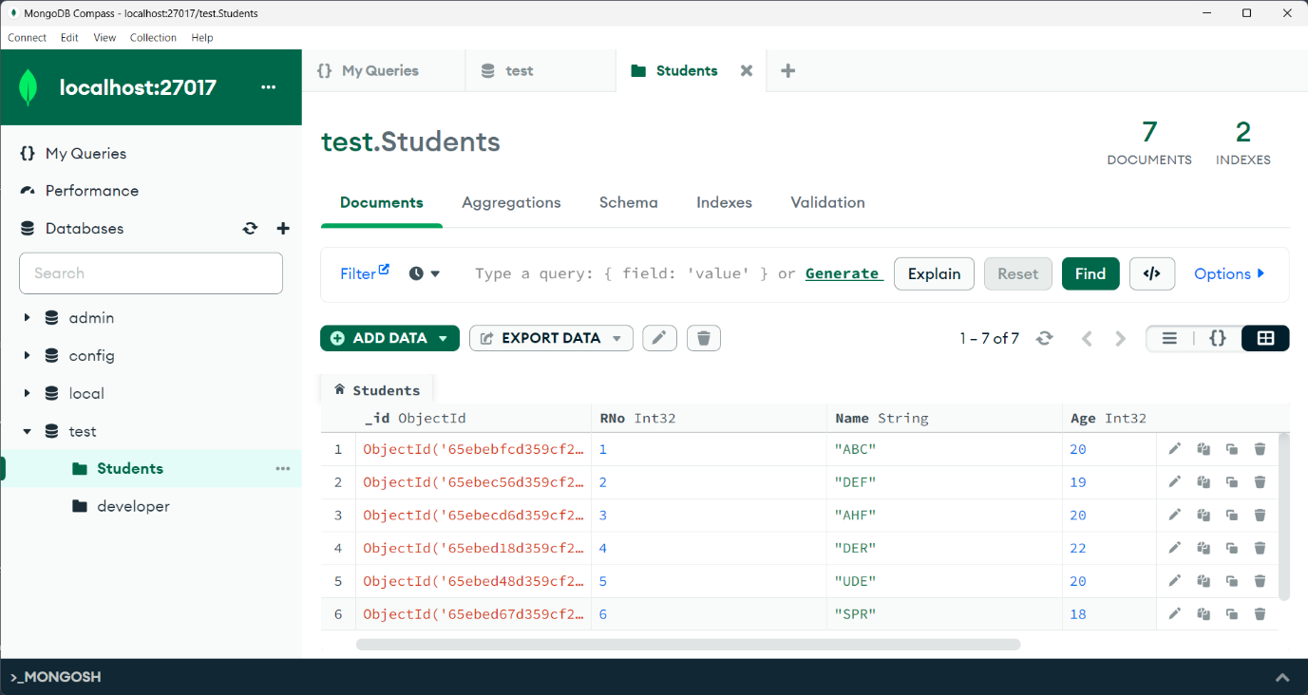

**Indexing Creation**

**As rno is the unique attribute throug which we identify a student uniquely. So, here I created an index based on Rno. And assigned unique key to it.**

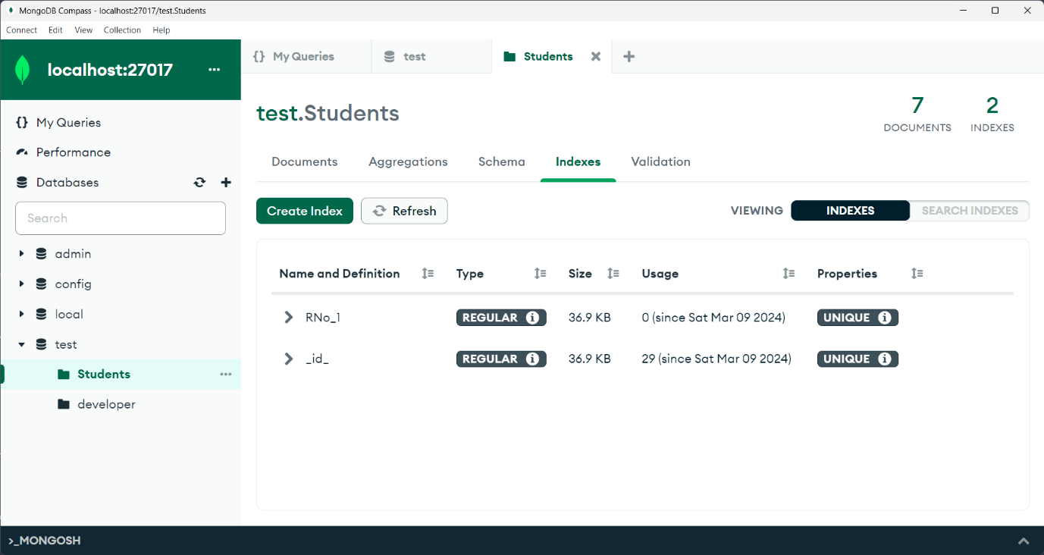

**Indexing usage**

**As we gave Rno as unique, If we try to insert a duplicate document that is existed it shows an error like..duplicate collection.**

